Candidate’s Name: ………………………………………………………… Assessment Number: …………………………………………
School Name: ……………………………………………………………………. School Code: …………………………………………………………
Candidate’s Signature: ………………………………..…………….Date: …………………………………………………….…………….
COMPETENCE BASED EDUCATION
KENYA JUNIOR SCHOOL EDUCATION ASSESSMENT
903 MATHEMATICS
JUNE 2025 Time: 2 hours
INSTRUCTIONS TO CANDIDATES
- Fill the required information in the above data space
- Sign and write the date of the assessment in the spaces provided above.
- This question paper consists of TWO sections: A and B.
- Answer ALL the questions in section A on the separate ANSWER SHEET provided.
- Answer ALL the questions in section B in the spaces provided in this QUESTION PAPER.
- Show all the workings in section B in the spaces provided.
- Non-programmable calculators may be used, except where stated otherwise.
- Give non-exact numerical answers, correct to 3 significant figures, and one decimal place for angles in degrees, unless a different level of accuracy is specified in the question.
- For π, use either the calculator value or 3.142.
- Do NOT remove any page from this question paper.
- Answer ALL the questions in English.
For official use only
Section | Task | Question Numbers | Max. Score | Score
B
 | Task 1 | 21, 22, 23 | 18
 | Task 2 | 24, 25 | 12
 | Task 3 | 26, 27, 28 | 20
 | Task 4 | 29, 30, 31 | 18
 | Task 5 | 32, 33, 34 | 12
 |  | Total
This paper consists of 15 printed pages. Candidates should check the question paper to ascertain that all the pages are printed as indicated and that no questions are missing. © 2025, The Competence Based Assessment Turn over

SECTION A (20 marks)
Answer all the questions in this section.
- You have been given this question paper and a separate answer sheet. Answer All the questions in Section A on the separate answer sheet provided.
- When you have chosen your answer, mark it on the ANSWER SHEET, not in this question paper.
HOW TO USE THE ANSWER SHEET
- Use an ordinary HB pencil.
- Confirm that the answer sheet you have been provided with has the following:
YOUR ASSESSMENT NUMBER YOUR NAME
NAME OF YOUR SCHOOL NAME OF THE SUBJECT
- Keep the answer sheet clean, dry and DO NOT fold it.
- For each of the questions 1 – 20, four answers are given. The answers are lettered A, B, C and D. In each case, only ONE of the four answers is correct. Choose the correct answer.
- On the answer sheet, the correct option is to be shown by drawing a dark line inside the box in which the letter you have chosen is written.
Example:
In the Question Booklet:
  - The area of a square plot is 144 m2. What is the length of one side of the plot?
A. 10 m B. 12 m C. 14 m D. 144 m
The correct answer is B.
On the answer sheet, in the set of boxes given for number 15, draw a dark line inside the box with the letter B printed in it as indicated below.
15 [A] [B] [C] [D]
- Your dark line MUST be inside the box.
- For each question, ONLY ONE box is to be marked in each set of four boxes.

SECTION A (20 marks)
Answer all the questions in this section.

- Round off 15.678 to two decimal places. A. 15.67 B. 15.68 C. 15.70 D. 16.00
- What is the greatest common divisor (GCD) of 12, 18, and 30? A. 3 B. 6 C. 12 D. 180
- A map has a scale of 1:20000. What is the actual distance represented by a length of 5 cm on the map? A. 100 m B. 1000 m C. 10 km D. 100 km
- The coordinates of point P are (2,3). If point P is translated by the vector (1−2​), what are the new coordinates of P'? A. (3,1) B. (1,5) C. (3,5) D. (1,1)
- A class has 25 boys and 30 girls. What is the ratio of boys to girls in simplest form? A. 25:30 B. 5:6 C. 6:5 D. 5:11
- In a right-angled triangle, if the opposite side to angle θ is 8 cm and the adjacent side is 6 cm, what is the value of tanθ? A) 68​ B) 86​ C) 108​ D) 106​
- A triangular prism has a base which is an equilateral triangle. How many faces does the prism have? A. 3 B. 4 C. 5 D. 6

WORKING SPACE

- The diagram below shows an angle.
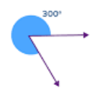

What type of angle is shown? A. Acute angle B. Obtuse angle C. Reflex angle D. Right angle
- Convert 2.5 hours into minutes. A. 120 minutes B. 150 minutes C. 205 minutes D. 250 minutes
- A shopkeeper buys a book for Ksh 400 and sells it for Ksh 500. What is the percentage profit? A. 20% B. 25% C. 100% D. 125%
- Evaluate (−10)× 5−(−20). A) -70 B) -30 C) 30 D) 70
- Simplify k⁹÷k³. A) k³ B) k⁶ C) k¹² D) k²⁷
- If a bag contains 5 red and 7 blue balls, what is the probability of picking a blue ball? A) $\frac{5}{12​}$ B) $\frac{7}{12​}$ C) $\frac{5​}{7}$ D) $\frac{7}{5​}$

- An object has a mass of 150 grams and a volume of 50cm3. What is its density? A) 0.3g/cm3 B) 3g/cm3 C) 100g/cm3 D) 7500g/cm3

WORKING SPACE

- Given
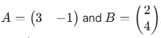
What is the product AB?
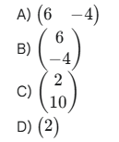
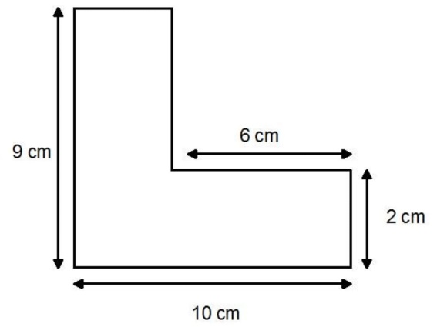
- Studythe shape below and answer the question.

What is the total area of the shape? A) 50cm² B) 48cm² C) 100cm² D) 125cm²
- If 4 men can build a wall in 6 hours, how long will it take 8 men working at the same rate? A) 3 hours B) 6 hours C) 12 hours D) 48 hours
- What is the gradient of the line
y=−2x+5? A) -2 B) 5 C) 2 D) -5
- Which integer is a solution to the inequality 3x+1<10? A) 3 B) 4 C) 5 D) 6
- The bearing of town B from town A is 045∘. What is the bearing of town A from town B?
A. 045∘ B. 135∘ C. 225∘ D. 315∘

SECTION B (80 marks)
Answer all the questions in the spaces provided. Show all your working.
Task 1 (18 Marks)
- A farmer harvested 3567890 kg of maize in one season. (a) Write this number in words. (2 marks)
________________________________________________________________________
________________________________________________________________________
(b) Write the number in standard form. (1 mark)

(c) Round off the number of kilograms to the nearest thousand. (1 mark)

- In a certain month, a family spent $¼​$ of their income on food, $\frac{2​}{5}$ on rent, and saved the rest. (a) What fraction of their income was spent on food and rent? (2 marks)

(b) What fraction of their income was saved? (2 marks)

(c) If the family's income for the month was Ksh 60000, how much money did they save? (2 marks)

- A shop offers a 15% discount on all items. A customer bought a dress with a marked price of Ksh 4800. (a) Calculate the amount of discount given. (2 marks)

(b) Calculate the price the customer paid for the dress. (2 marks)

- A sum of Ksh 50000 is invested at a simple interest rate of 12% per annum for 3 years. (a) Calculate the simple interest earned after 3 years. (2 marks)

(b) Calculate the total amount after 3 years. (2 marks)

Task 2 (12 Marks)
- Simplify the following algebraic expressions: (a) 5p−3q+2p+7q (2 marks)

(b) 4(2m−3)−(5m+1) (3 marks)

- Solve the following equations: (a) 3x​+4=9 (2 marks)

(b) 3(y+2)=15 (2 marks)

(c) Solve the inequality 2k+3<9 and represent the solution on a number line. (3 marks)

Task 3 (20 Marks)
- The base of a rectangular tank is 3.5 m long and 2 m wide. Water is filled into the tank to a height of 1.2 m. (a) Calculate the area of the base of the tank. (1 mark)

(b) Calculate the volume of water in the tank in cubic metres. (2 marks)

(c) Convert the volume of water to litres. (1 mark)

- A cylindrical container has a radius of 7 cm and a height of 10 cm. (Use π=$\frac{22}{7}$ ​) (a) Calculate the area of the base of the cylinder. (2 marks)

(b) Calculate the volume of the cylinder. (2 marks)

(c) Calculate the curved surface area of the cylinder. (2 marks)

(d) Calculate the total surface area of the closed cylinder. (2 marks)

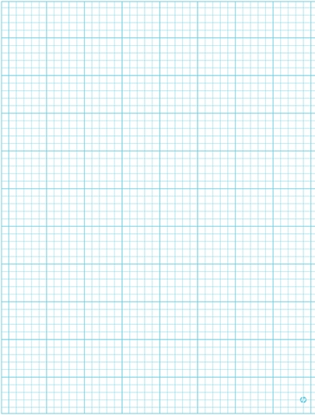
- The vertices of a triangle ABC are A (1,2),B(3,2),and C(3,5). (a) Plot triangle ABC on the Cartesian plane below. (Provide a grid for plotting) (3 marks)

(b) Triangle ABC is translated by the vector ( $-\frac{1}{4}$ ​) to form triangle A'B'C'. Determine the coordinates of A', B', and C'. (3 marks)
A': (______ ,______ )
B': (______ ,______ )
C': (______ ,_______)

Task 4 (18 Marks)
- Three workers, Ann, Ben, and Chris, are paid Ksh 12000, Ksh 15000, and Ksh 18000 respectively per month. (a) Write their salaries as a ratio in simplest form. (2 marks)

(b) If they decide to share a bonus of Ksh 9000 in the ratio of their salaries, how much will each receive?

Ann: ___________ Ben: ___________ Chris: ___________ (4 marks)
- A car travels a distance of 240 km in 3 hours. (a) Calculate the average speed of the car in km/h. (1 mark)

(b) Convert the speed to m/s. (2 marks)

(c) How long would it take the car to travel 300 km at the same speed? (2 marks)

- 5 men can dig a trench in 10 days. Assuming they work at the same rate, how many days would it take 8 men to dig the same trench? (3 marks)

- Given the matrices A= 2 3​​ and B= 4 −1​ ​.
1 0 5 2

(a) Calculate A+B. (2 marks)

(b) Calculate 2A. (2 marks)

Task 5 (12 Marks)
- The data below shows the scores of 10 learners in an Integrated science test:

65, 72, 80, 55, 72, 62, 78, 85, 72, 68

(a) Arrange the scores in ascending order. (1 mark)

____________________________________________________________________
(b) Determine the mode of the scores. (1 mark)

_____________________________________________________________________
(c) Determine the median of the scores. (2 marks)

(d) Calculate the mean score. (3 marks)

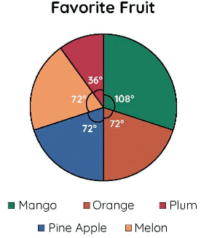
- The pie chart below represents the favourite fruits of a group of 180 learners.
X⁰

(a) Calculate the angle representing learners whose favourite fruit is Mango. (1 mark)

(b) Calculate the number of learners whose favourite fruit is plum. (2 marks)

(c) How many more learners prefer Mango than pine apple? (2 marks)

THIS IS THE LAST PRINTED PAGE.

Marking scheme
SECTION A (20 marks
- B.
- B.
- B.
- A.
- B.
- C.
- C.
- B.
- B.
- B.
- B.
- B.
- B.
- B.
- A.
- C.
- A.
- A.
- A.
- C.
SECTION B
21.
(a) Three million, five hundred and sixty-seven thousand, eight hundred and ninety.
(b) (3.567890 ×10⁶)
(c) 3568000 kg
22. (a) $\frac{13}{20}$
(b) $\frac{7}{20}$
(c) Ksh 21000
23. (a) Ksh 720
(b) Ksh 4080
24.
(a) Ksh 18000
(b) Ksh 68000
25.
(a) (7p + 4q)
(b) (3m - 13)
26.
(a) (x = $\frac{5}{3}$)
(b) (y = 3)
(c) (k < 3), Number line with open circle at 3 and arrow to the left.
27.
(a) (7 , m²)
(b) (8.4 , m³)
(c) 8400 litres
28.
(a) (154 , cm²)
(b) (1540 , cm³)
(c) (440 , cm²)
(d) (748 , cm²)
29.
(a) Plot of A(1,2), B(3,2), C(3,5) on a Cartesian plane.
(b) A'(3, 1), B'(5, 1), C'(5, 4)
30.
(a) 4 : 5 : 6
(b) Ann: Ksh 2400, Ben: Ksh 3000, Chris: Ksh 3600
31.
(a) 80 km/h
(b) 22.2 m/s (to 1 decimal place)
(c) 3.75 hours
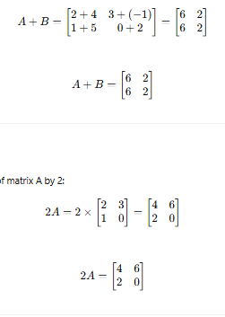
32. 6.25 days
33. (a)

(b)

34.
(a) 55, 62, 65, 68, 72, 72, 72, 78, 80, 85
(b) 72
(c) 72
(d) 70.9
35.
(a) (108⁰)
(b) 18 learners
(c) 18 more learners

